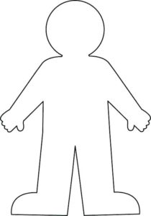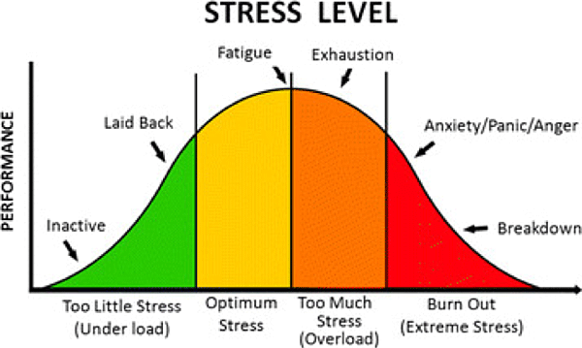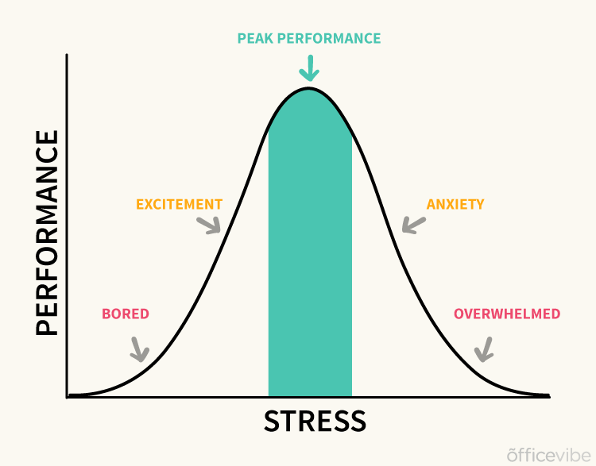

**Relaxing all of your senses**

Doodle here for stress relief 😉

Ten things that stress me out are … (name no names)

1 _____________________ 2 _____________________ 3 _____________________ 4 _____________________ 5 _____________________ 6 _____________________ 7_____________________ 8 _____________________ 9______________________ 10 ____________________

* Colour code them to show how many are school related
* Colour code any that are related to social media
* Colour code any about self-image and how you feel about yourself
* Colour code any you think you could take control of
* Colour code the things you can’t control

What do you need to hear when you’re trying to reduce stress? ____________________________________________________________________________ and what don’t you want to hear? _______________________________________

What do you need to see when you’re trying to reduce stress? ____________________________________________________________________________ and what don’t you want to see? _______________________________________

What do you need to feel when you’re trying to reduce stress? ____________________________________________________________________________ and what don’t you want to feel? _______________________________________

Think about smells and tastes too … ________________________________________

**Handling Stress and making it work for me …**

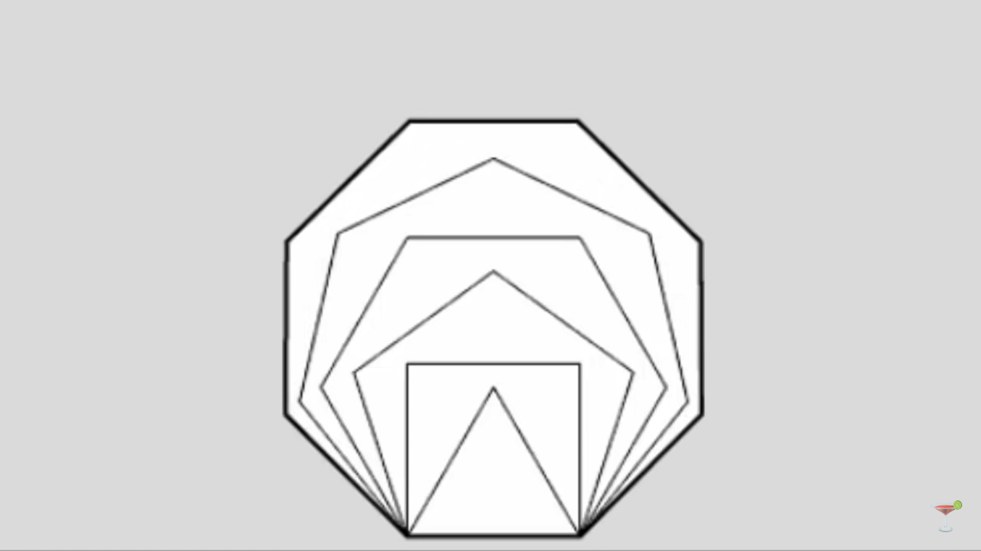

Doodle here for stress relief 😉

5 (honest) things I need to do to be less stressed about exams are …

1 ____________________________ because ____________________ _________________________________________________________

2 ____________________________ because ____________________ _________________________________________________________

3 ____________________________ because ____________________ _________________________________________________________

4 ____________________________ because ____________________ _________________________________________________________

5 ____________________________ because ____________________ _________________________________________________________

<https://www.youtube.com/watch?v=Wdbbtgf05Ek>

Remember … being prepared and organised, eating well, sleeping well all have an impact on how well you do in your exams … not just how clever you are!

On the morning of the exam I make sure that I have ….

The night before the exam I make sure that I have ….

The weekend before the exam I make sure that I have ….

1 or 2 weeks before the exam I make sure that I have ….